IIHT

movie booking App
Contents
1 Problem Statement 1
2 Proposed Movie Booking App Wireframe 1
3 Application Architecture 1
4 Tool Chain 1
5 Development flow 2
6 Business-Requirement: 3
7 Rubrics/Expected Deliverables 4
7.1 Rest API (Products & Frameworks -> Compute & Integration): 4
7.2 Database (Products & Frameworks -> Database & Storage): 5
7.3 Maven (Tooling): 5
7.4 Unit Testing: 5
7.5 Debugging & Troubleshooting 5
7.6 Code quality & Code coverage 5
7.7 Good To Have: 5
8 Frontend 5
9 Expected Outcomes: 5
9.7.1 MovieBookingApp Home Page 5
9.7.2 Search By Movie Name 5
9.7.3 Registration Page Validation 5
9.7.4 Registration Page Validation (Password Validation criteria) 5
9.7.5 Registration Page Validation (Password Do not Match) 5
9.7.6 Successful Registration 5
9.7.7 Forgot Password _Reset_option 5
9.7.8 Login Page 5
9.7.9 Home Page After Successful Login 5
9.7.10 Sold Out Option Disables Tickets Booking 5
9.7.11 Can View the Tickets Booked by Logged In User 5
9.7.12 Ticket Book Page 5
9.7.13 Logged In User Can reset the Password Using Change Password Option 5
9.7.14 Change Password Validation 5
9.7.15 Admin Login 5
9.7.16 Admin Dashboard After Login 5
9.7.17 Movie added By Admin (Movie Name-Sigma) 5
9.7.18 Added Movie Reflected in Dashboard 5
9.7.19 Admin Can Manually Mark Movie As SOLD OUT 5
9.7.20 Admin Can Manually Mark Movie As BOOK ASAP 5
9.7.21 Through Refresh Availability Option Ticket Status will be Set again 5
9.7.22 Normal Logged in User Can see the newly added Movie and Can book the tickets 5
9.7.23 Ticket Book Validation Functionality 5
9.7.24 Successful Ticket Booked 5
9.7.25 Now the Movie Ticket Booking Status Changes Based on Ticket Availability 5
9.7.26 Ticket Also reflected in Ticket List 5
9.7.27 In Admin Dashboard Also, changes Reflected through Refresh Availability option 5
9.7.28 Admin Can Delete the Movie 5
9.7.29 Admin Dashboard After Deleting Sigma Movie 5
9.7.30 In User Home Page Movie Removed 5
9.7.31 The ticket was also Removed for the Respective Deleted Movie 5

Problem Statement
Movie Booking App is an application that allows the users to register and login and search movies released. User can book the tickets for the movies they wish for. Admin shall view the tickets booked and update the pending tickets available to the system.
Guest users cannot book any tickets.
The core modules of movie booking app are:
- User registration and login
- Browse the movies released and list of theatres
- User can book the tickets
- Admin to update the available ticket status based on the tickets booked
The scope includes developing the application using toolchain mentioned below.

Proposed Movie Booking App Wireframe
      - UI needs improvisation and modification as per given use case.
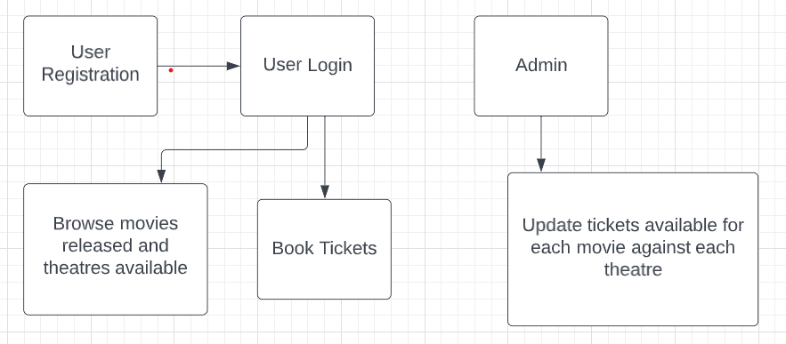

Application Architecture

index.html
App Module (Root Module)
Root Component
Movie Booking App Component

Movie Booking App Services

Presentation (Products & Frameworks)

GIT
Spring Boot Rest API &
Microservices
Junit

OpenAPI

Compute & Integration (Products & Frameworks)

DB
Database & Storage (Products & Frameworks)

Tool Chain
Competency | Skill | Skill Detail
Engineering Mindset | Networking and Content Delivery
 | Ways of Working
 | Consulting Mindset
 | DevOps
Programming Languages | Application Language | Java
Products & Frameworks | Presentation | Angular/React
 |  | Karma & Jasmine
 |  | Jest & Cypress
 | Compute & Integration | Spring Boot
 | Database & Storage | MySQL/SQL-Server
 | Governance & Tooling | Git
 |  | Maven
 |  | JUnit 5/Mockito

Development flow
No | MC | Competency | Section | Indicative  Mechanism for Evaluation (Passing score of 60% in each MC)
Business Requirement
1 | Backend | Rest API, Database, Testing, Debugging & Troubleshooting | Click here | Code Submission and Evaluation, Panel Presentation
2 | Front End | Angular/React | Click here | Code Submission and Evaluation, Panel Presentation

Business-Requirement:
As an application developer, develop frontend, middleware and deploy the Movie Booking App with below guidelines:
Pre-requisite before implementing the user story:
Create a static database as “Movie” and add the below fields
- Movie name, Total number of tickets allotted and theatre name (Movie name and theatre name should be of composite primary key)
There should be a predefined set of tickets assigned to each theatre against each movie. Just create sample 2 movies with 2 theatres assigned. This will be used for the upcoming user story to fetch the data.
User  Story # | User Story Name | User Story
US_01 | Registration and Login | As a user I should be able to login/Register in the movie booking application  Acceptance criteria:  - A logged-in user can reset their password so they can login, even if they forget their password.  - A logged-in user:  - Cannot change their username.  - Can logout from their account.  - As a customer I should be able to furnish following details at the time of registration  - First Name  - Last Name  - Email  - Login Id  - Password  - Confirm Password  - Contact Number  - All details fields must be mandatory  - Login Id and Email must be unique  - Password and Confirm Password must be same  - If any constraint is not satisfied, validation message must be shown
US_02 | View &Search Movies | As a user I should be able to view all the recent movies opened for booking. User can search any particular movies as well  Acceptance criteria:  - User can view all the existing released movies.  - User can search any particular movie based on the movie name
US_03 | Book Tickets for a movie | As a user I should be able to book tickets for a movie. Add this booking to a database table “Tickets”. Assign movie name and theatre name as a foreign key to database table “Movie” which is already created as a pre-requisite  Acceptance criteria:  - Book a movie ticket  - Below are the details to be added  - Movie Name  - Theatre name  - Number of tickets  - Seat Number
US_04 | View booked tickets and Update ticket status | As an admin I should be able to view booked tickets and update the balance tickets available for a movie  Acceptance criteria:  - View number of booked tickets for a particular movie from table “Tickets”  - Check the tickets available from table “Movie” by calculating the total tickets booked  - If the quantity is 0, update the ticket status as ‘SOLD OUT’, else update as ‘BOOK ASAP’

Rubrics/Expected Deliverables

Rest API (Products & Frameworks -> Compute & Integration):
  - Use Spring Boot to version and implement the REST endpoints.
  - Implement HTTP methods like GET, POST, PUT, DELETE, PATCH to implement RESTful resources:
POST | /api/v1.0/moviebooking/register | Register as new user
GET | /api/v1.0/ moviebooking /login | Login
GET | /api/v1.0/ moviebooking /<username>/forgot | Forgot password
GET | /api/v1.0/ moviebooking /all | View all movies
GET | /api/v/1.0/moviebooking/movies/search/moviename* | Search by movie name
POST | /api/v1.0/ moviebooking /<moviename>/add | Book tickets for a movie
PUT | /api/v1.0/moviebooking /<moviename>/update/<ticket> | Update ticket status
DELETE | /api/v1.0/ moviebooking /<moviename>/delete/<id> | Delete movie
  - *Movie name may be partial or complete username
  - Use necessary configuration in place for REST API in application. Properties or bootstrap. Properties or application.yml; whichever is applicable.
  - Package Structure for Spring Boot Project will be like com. moviebookingapp. * With proper naming conventions for package and beans.
  - Use configuration class annotated with @Configuration and @Service for business layer.
  - Use constructor-based dependency injection in few classes and setter-based dependency injection in few classes.
  - Follow Spring Bean Naming Conventions

Database (Products & Frameworks -> Database & Storage):
- As an application developer:
  - Implement ORM with Spring Data MongoRepositoryand MongoDB / JPARepository for other databases like SQL server/ MySQL. For complex and custom queries, create custom methods and use @Query, Aggregations (Aggregation Operation, Match Operation, Aggregation Results), implementation of MongoTemplateetc as necessary.
  - Have the necessary configuration in place for REST API in application.properties or bootstrap.properties or application.yml OR Java based configuration; whichever is applicable.
  - Implement SQL procedures, triggers, and other performance-enhancing techniques.
  - Implement at least 2 role-based authentications/authorisations in your Spring Boot applications.
  - Implement cache and session management techniques using the Spring Boot API.

Maven (Tooling):
      - As an application developer:
        - Create the spring boot project using Maven CLI
        - Generate Surefire test reports and share it as a part of deliverables
        - Using Maven CLI generate the project documentation, and share it as a part of the deliverables.

Unit Testing:
- As an application developer:
- Implement Unit testing using JUnit 5 for all the layers Exp: Controller layer, Service layer, and Repository layer.
- Generate the test results with positive and negative test scripts.

Debugging & Troubleshooting
- Generate bug reports & error logs - Report must be linked with final deliverables, which should also suggest the resolution for the encountered bugs and errors.

Code quality & Code coverage
- Ensure code quality with static analysis tools
- Code coverage for API should be > 80%

Good To Have:
- Implement error/exception handling mechanisms
- Implement logging and monitoring to detect and troubleshoot issues
- Implement rate limiting to prevent abuse of API endpoints
- Blogs should be fetched and displayed within 30 seconds
- Use containerization to package and deploy the application
- Improve maintainability with modular codebase, automated testing, CI/CD pipelines

Frontend
      - Develop the front end for all user stories.
      - Implement using either Angular or React
      - Implement all the Front-End validation rules
      - Proper naming conventions and folder structures
      - Implement using proper SOLID design principles
      - Perform unit and integration testing for the front-end application

Expected Outcomes:

MovieBookingApp Home Page

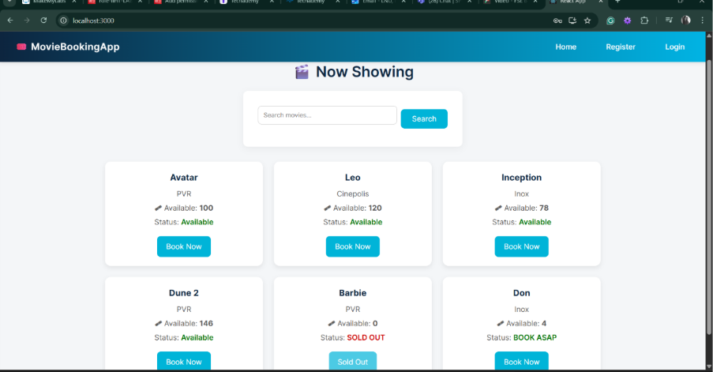

Search By Movie Name

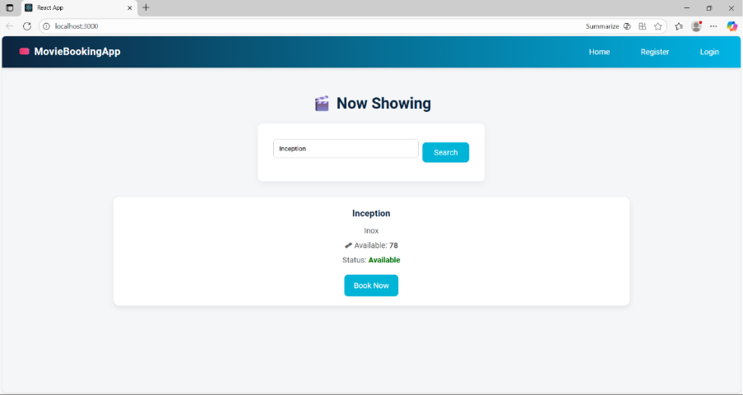

Registration Page Validation
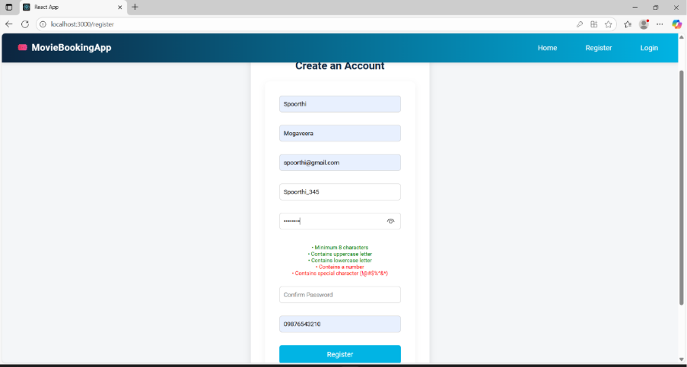

Registration Page Validation (Password Validation criteria)

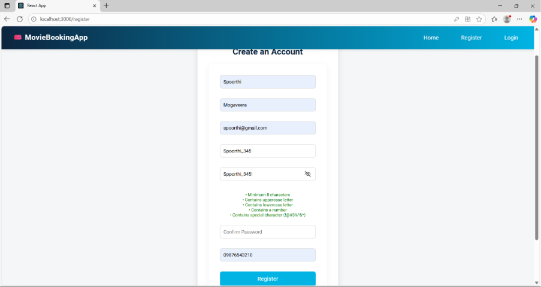

Registration Page Validation (Password Do not Match)

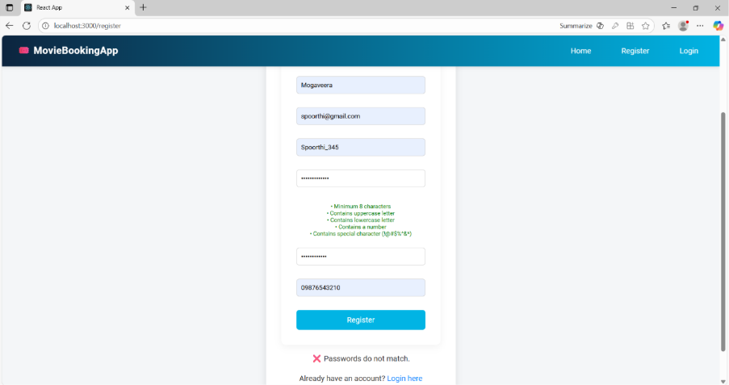

Successful Registration

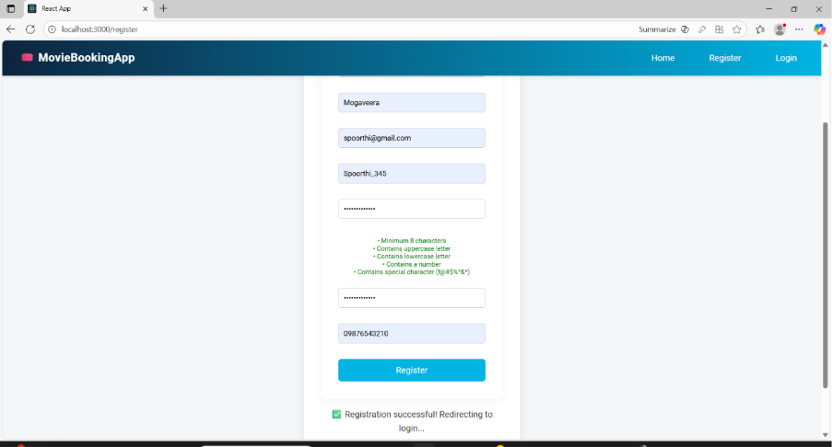

Forgot Password _Reset_option

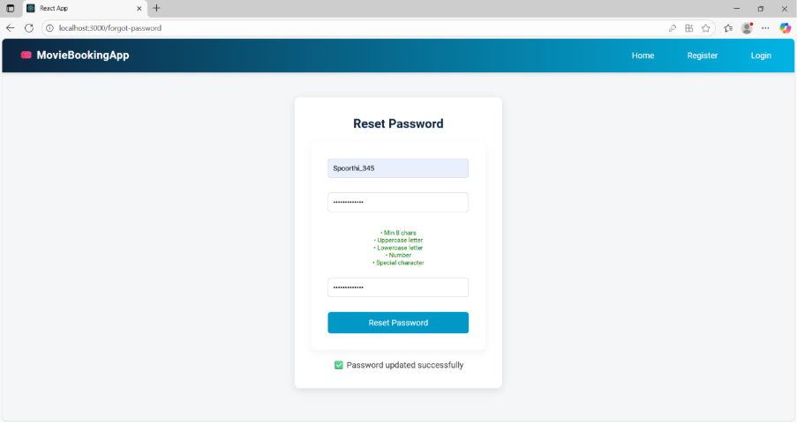

Login Page

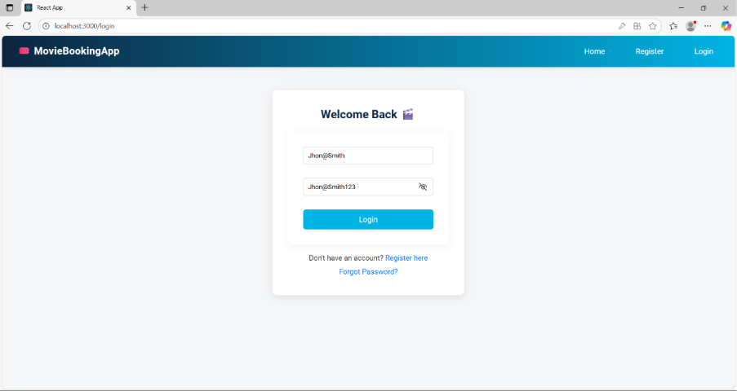

Home Page After Successful Login

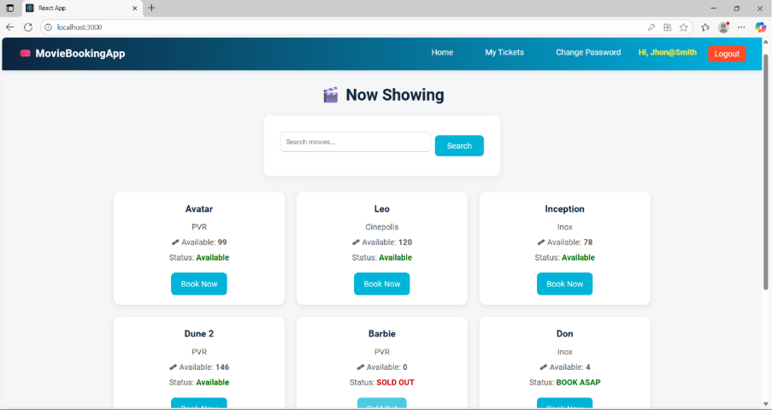

Sold Out Option Disables Tickets Booking

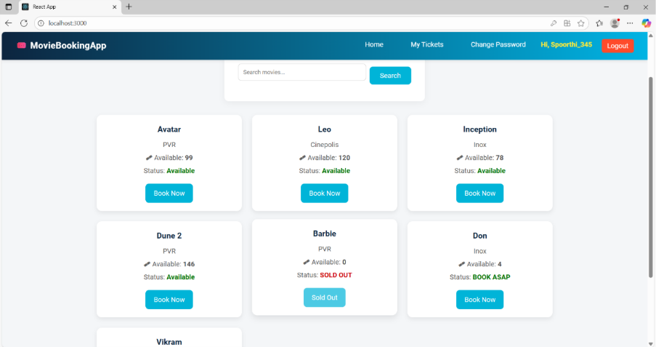

Can View the Tickets Booked by Logged In User
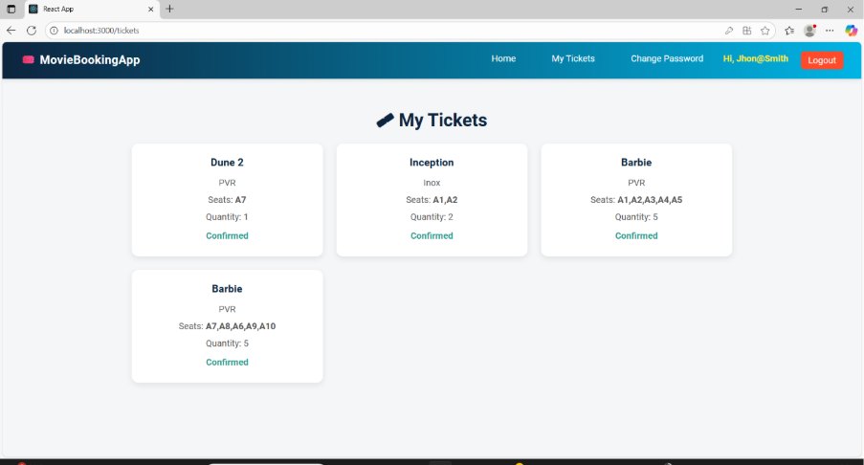

Ticket Book Page

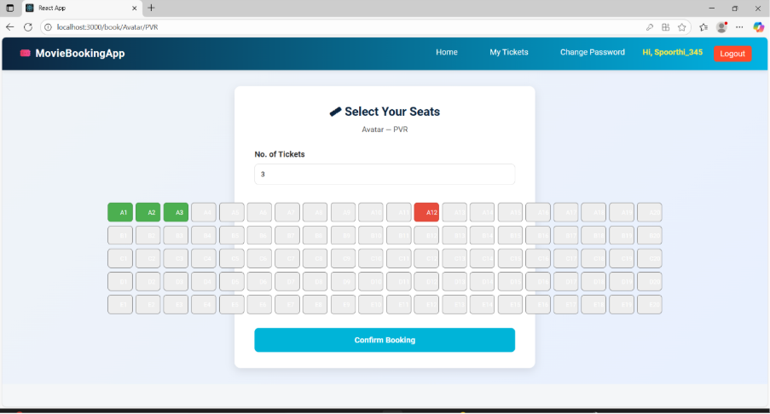

Logged In User Can reset the Password Using Change Password Option

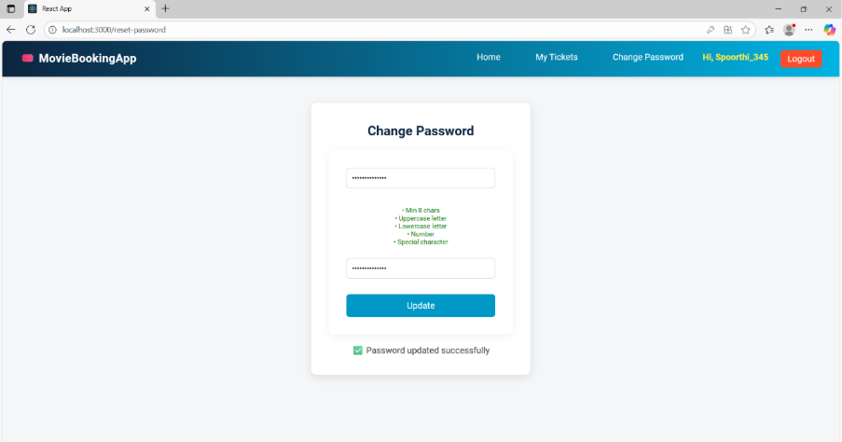

Change Password Validation

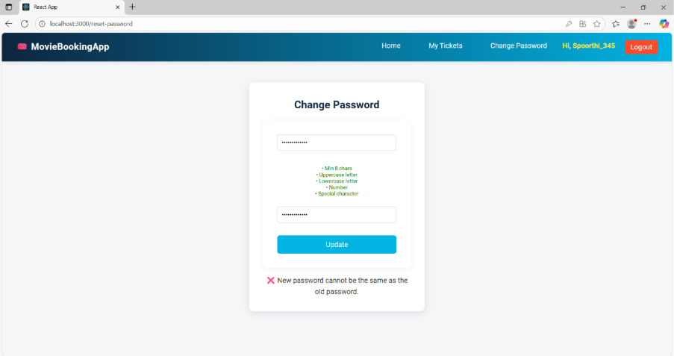

Admin Login
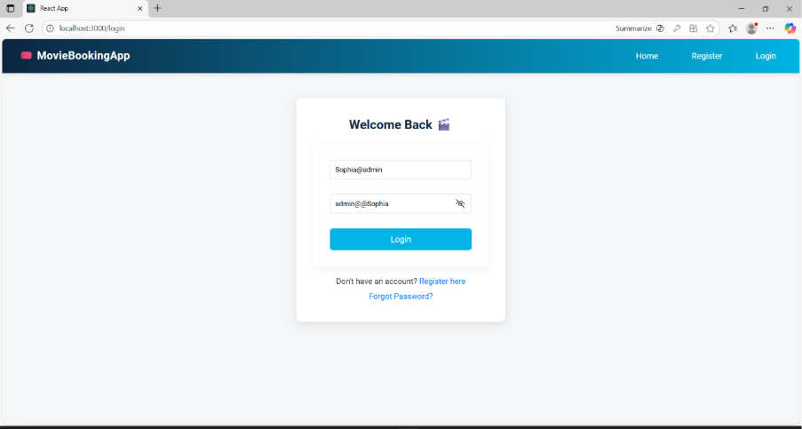

Admin Dashboard After Login

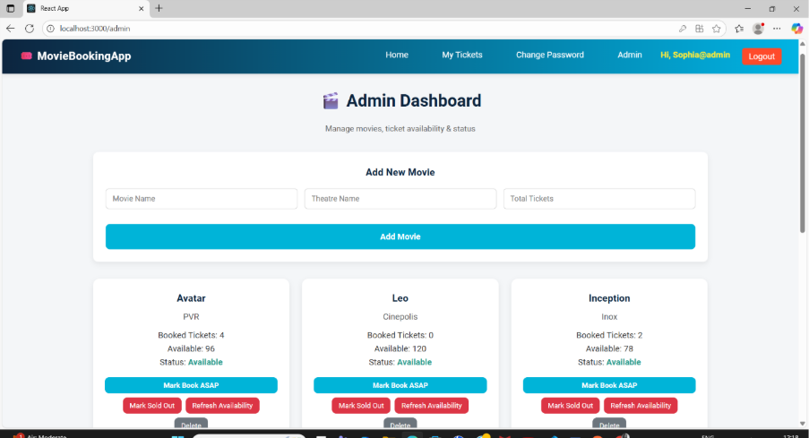

Movie added By Admin (Movie Name-Sigma)
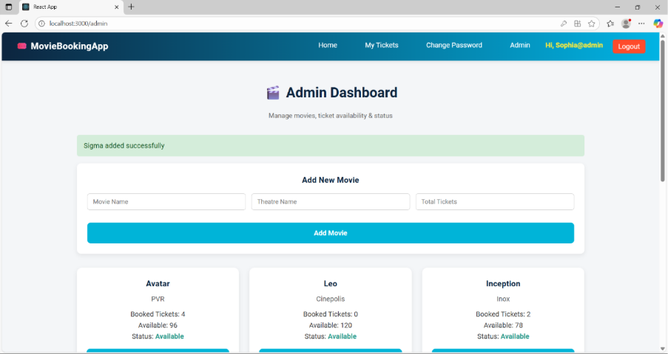

Added Movie Reflected in Dashboard

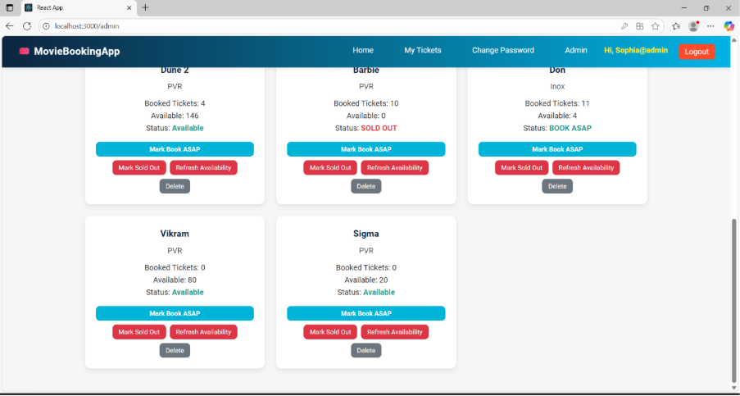

Admin Can Manually Mark Movie As SOLD OUT
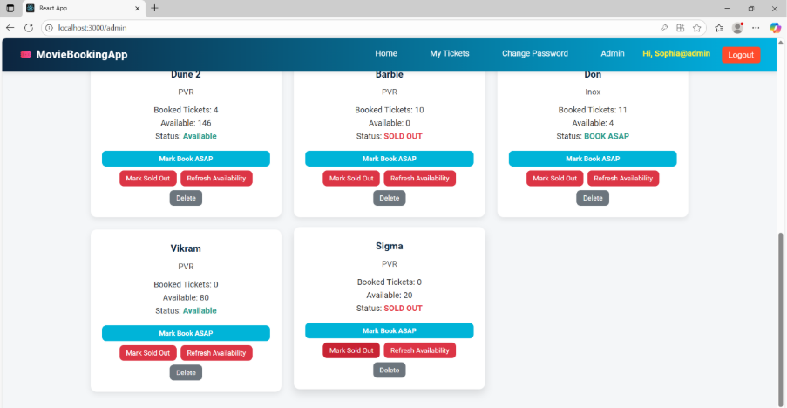

Admin Can Manually Mark Movie As BOOK ASAP

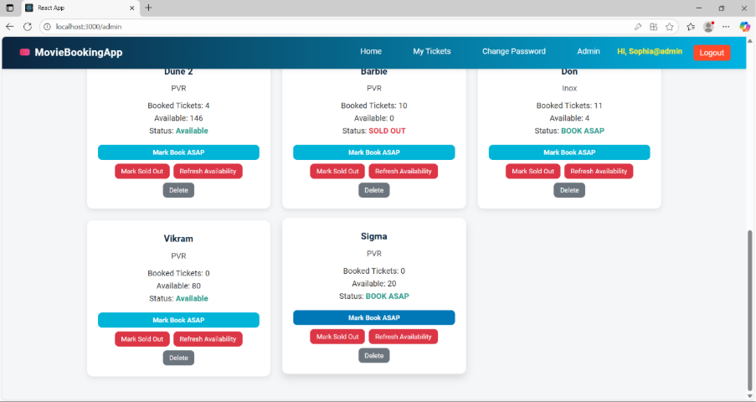

Through Refresh Availability Option Ticket Status will be Set again
Condition
- If Available tickets equal to Zero, Status Will be marked as SOLD OUT
- If Available tickets less than or equal to Half of the Total Tickets marked as BOOK ASAP.
- If Available tickets more than Booked Tickets, status will be marked as Available
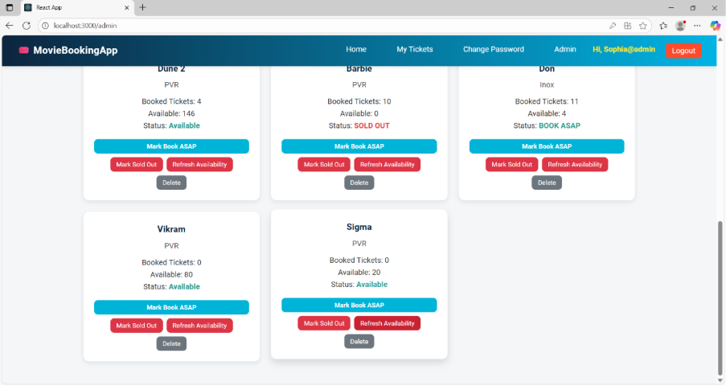

So here we are providing flexibility to admin, of Manually setting the status of Movie tickets booking and Automatically status changes based on ticket availability.

Normal Logged in User Can see the newly added Movie and Can book the tickets
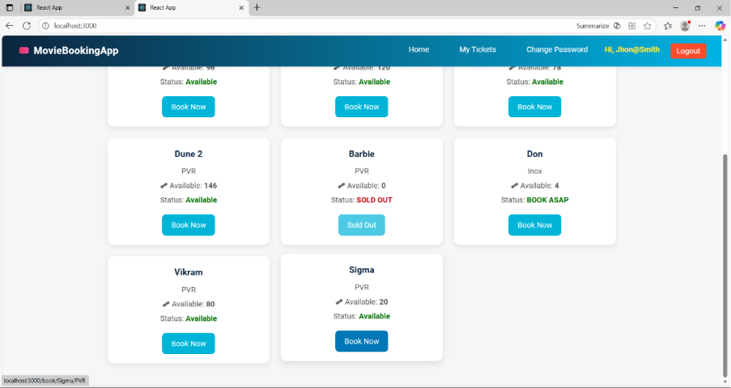

Ticket Book Validation Functionality
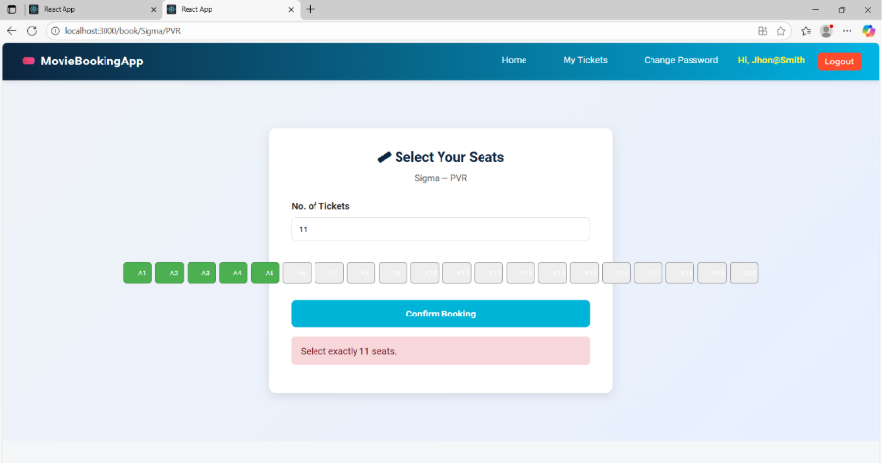

Successful Ticket Booked
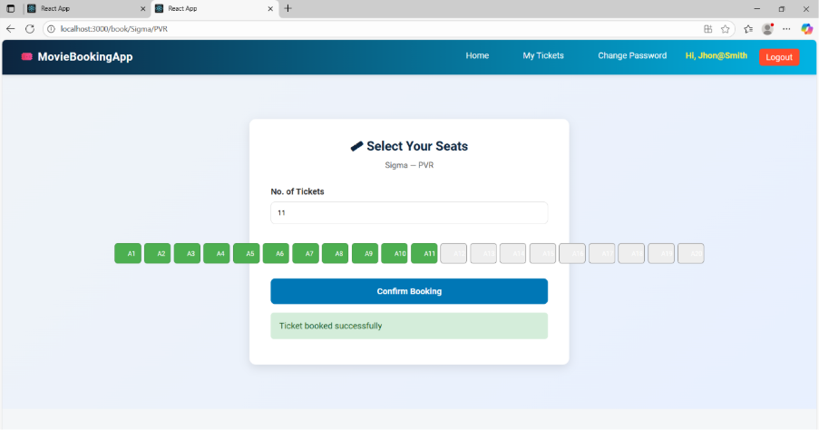

Now the Movie Ticket Booking Status Changes Based on Ticket Availability

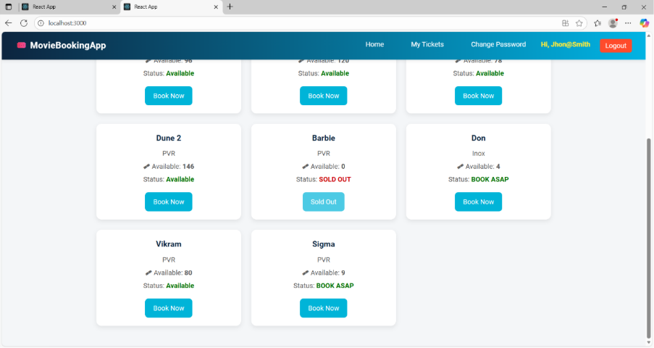

Ticket Also reflected in Ticket List
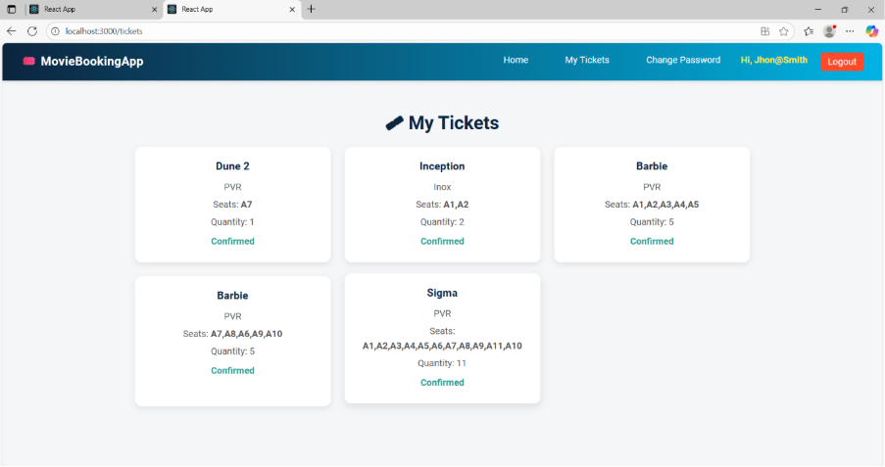

In Admin Dashboard Also, changes Reflected through Refresh Availability option

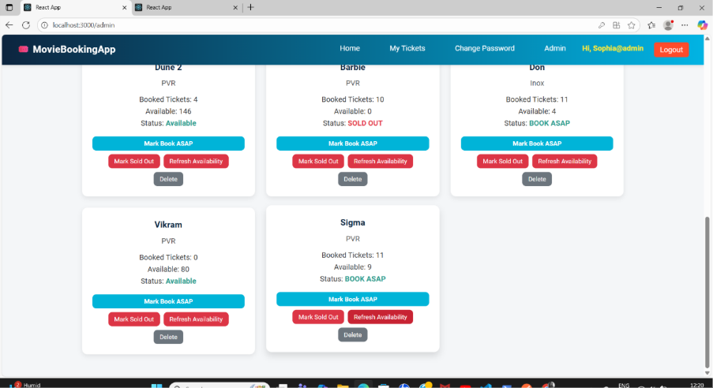

Admin Can Delete the Movie
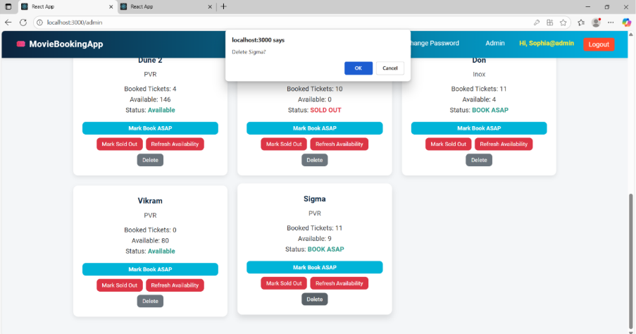

Admin Dashboard After Deleting Sigma Movie
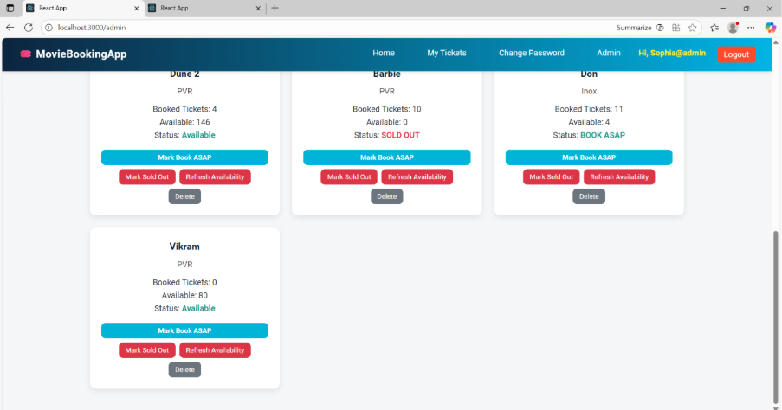

In User Home Page Movie Removed
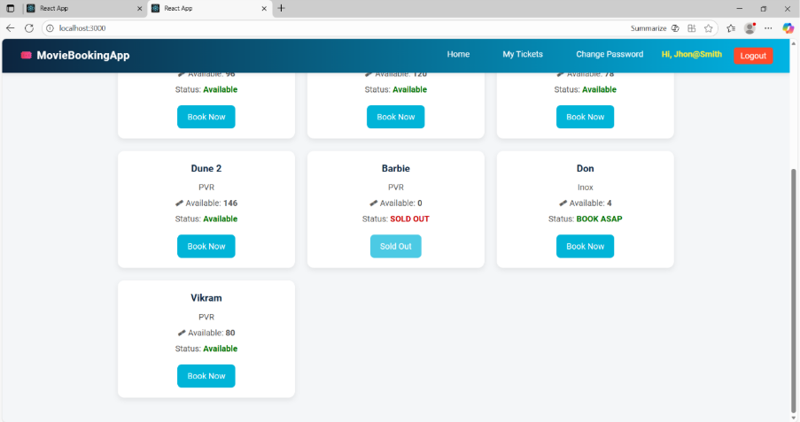

The ticket was also Removed for the Respective Deleted Movie
